LAB EXPERIMENT RECORD
Set 1: Monthly Sales Data

Department | AI&DS
Course Code / Course Name | DSA0602 / Data Handling and Visualization
Experiment | Data Visualization using R
Name | DEVAMADA HEMASREE
Register Number | 192524114
Date | 29 September 2026
Day | Tuesday

Set 1: Monthly Sales Data Dataset:
Aim
To visualize monthly sales data using a line chart, bar chart, and scatter plot, and to build an interactive dashboard using R and Shiny.
Dataset: Monthly Sales
Month | Sales ($)
January | 15000
February | 18000
March | 22000
April | 20000
May | 23000

PROGRAM 1: Line Chart
Aim: To create a line chart of monthly sales.
month <- c("January", "February", "March", "April", "May")
sales <- c(15000, 18000, 22000, 20000, 23000)

plot(sales, type = "o", xaxt = "n",
xlab = "Month", ylab = "Sales ($)",
main = "Monthly Sales", col = "blue")
axis(1, at = 1:5, labels = month)
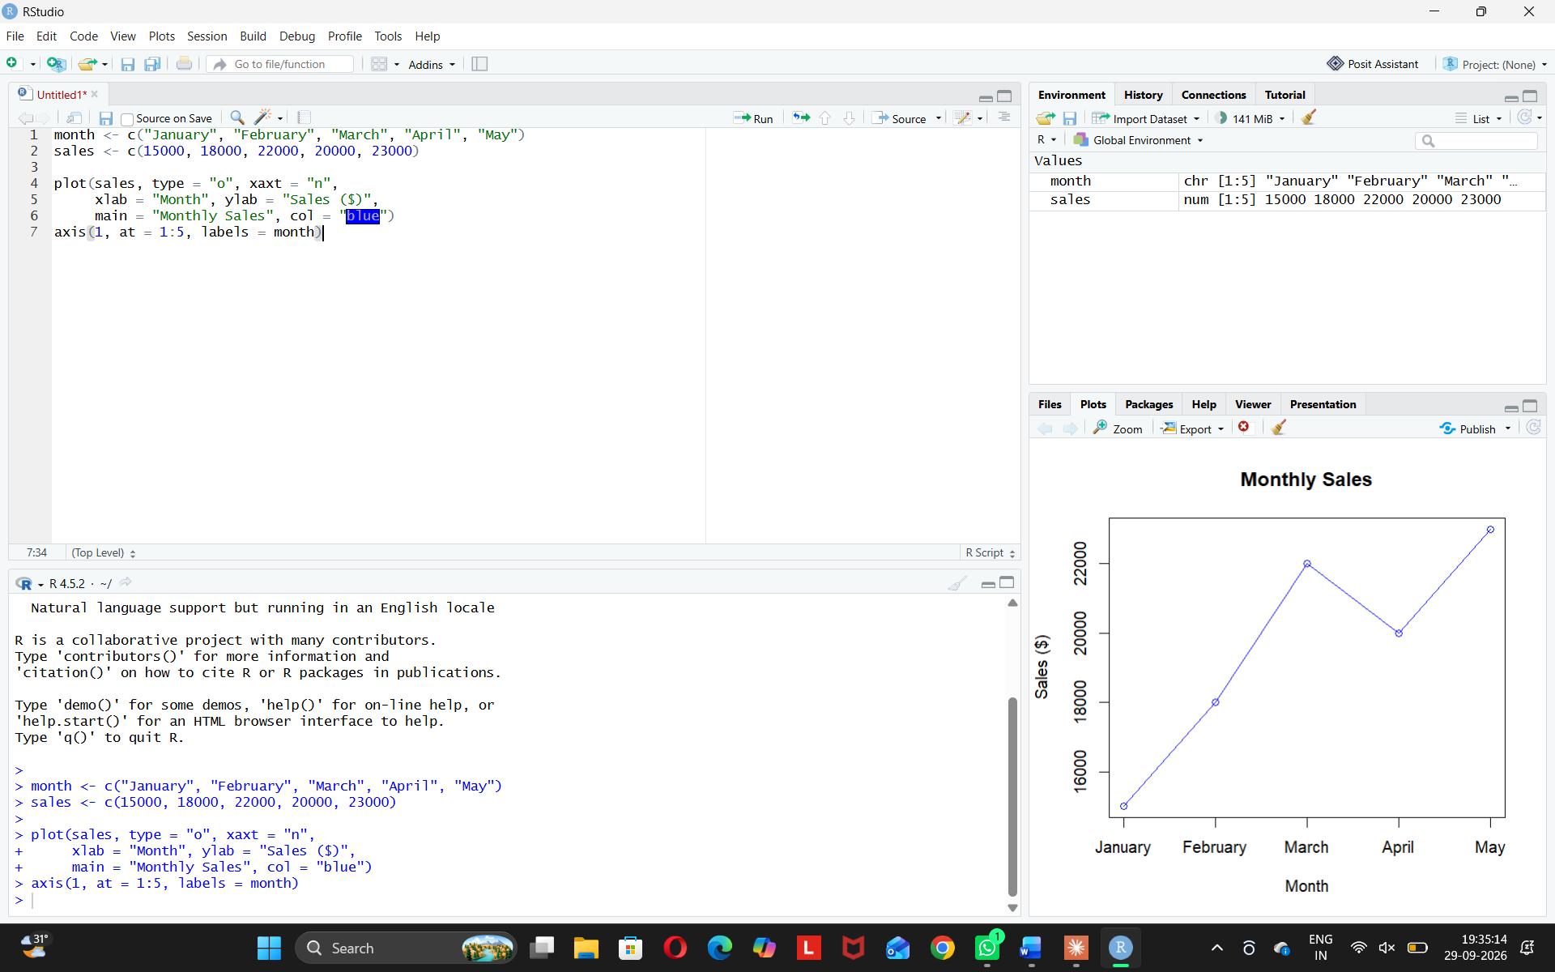
Observation: Sales rise from January to March, dip in April, and reach the highest in May.
PROGRAM 2: Bar Chart (Top-Selling Products)
Aim: To display the top-selling products using a bar chart.
products <- c("Phone", "Headphones", "Laptop", "Tablet", "Camera")
units <- c(200, 150, 120, 90, 60)

barplot(units, names.arg = products,
xlab = "Products", ylab = "Units Sold",
main = "Top-Selling Products", col = "orange")
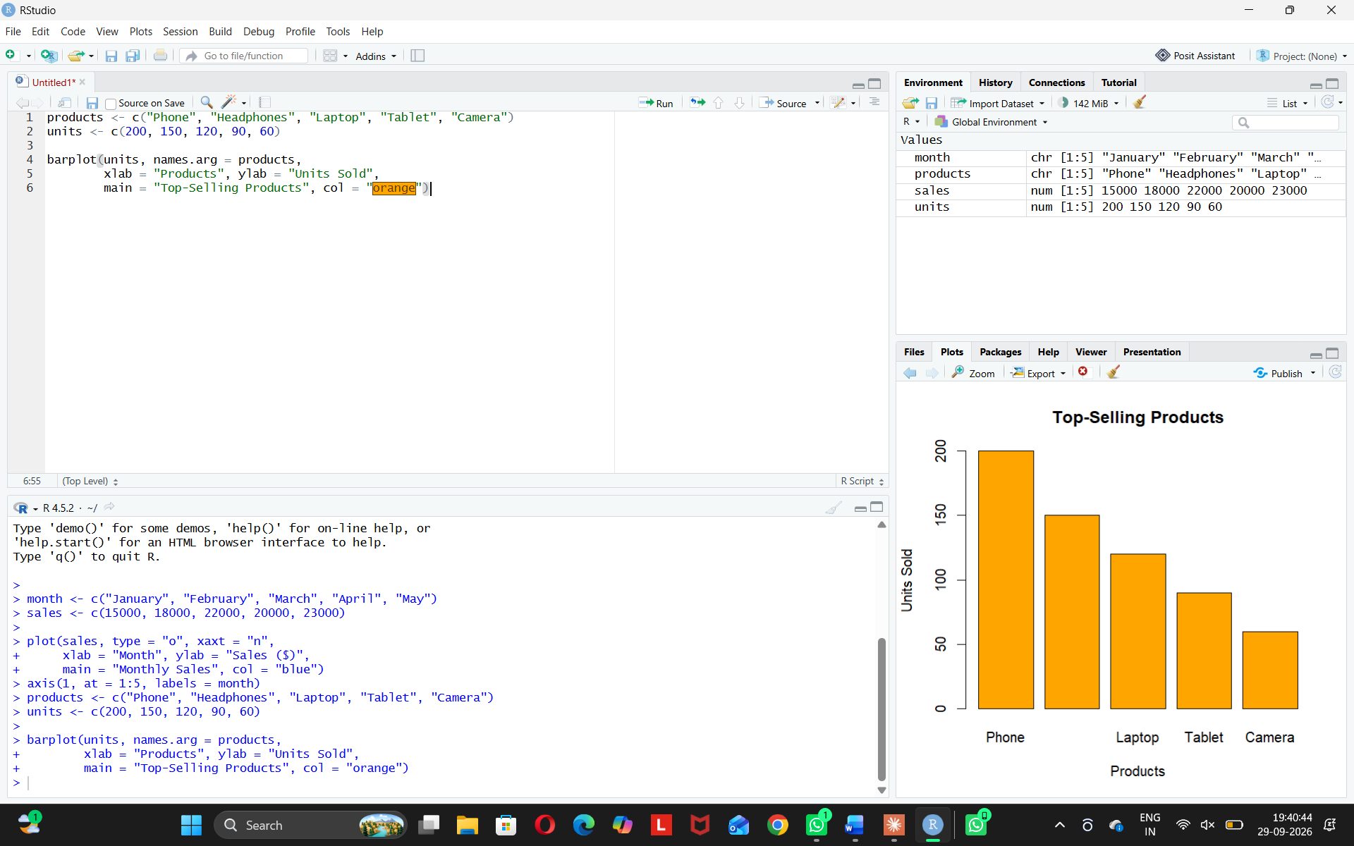
Observation: Phone is the top-selling product, followed by Headphones.
PROGRAM 3: Scatter Plot (Advertising Budget vs Sales)
Aim: To study the relationship between advertising budget and sales.
ad_budget <- c(2000, 2500, 3000, 3500, 4000)
sales <- c(15000, 18000, 22000, 20000, 23000)
plot(ad_budget, sales,
xlab = "Advertising Budget ($)", ylab = "Sales ($)",
main = "Advertising Budget vs Sales",
pch = 19, col = "red")
abline(lm(sales ~ ad_budget), col = "blue")
cor(ad_budget, sales)
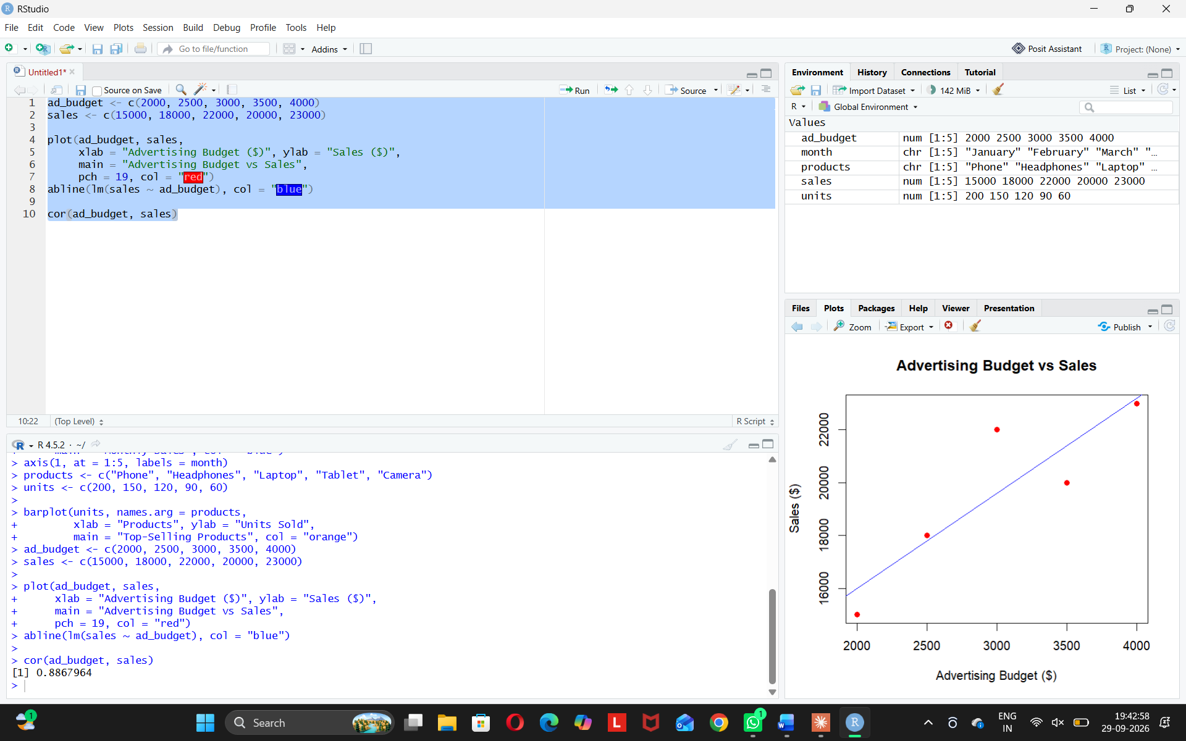
Insights:
- Higher advertising budget gives higher sales.
- Correlation is about 0.89, a strong positive relationship.
- Advertising is a good way to increase sales.

PROGRAM 4: Interactive Dashboard (Shiny)
Aim: To build an interactive dashboard with the line chart and bar chart.
install.packages("shiny")
if (!require(shiny)) {
install.packages("shiny")
library(shiny)
}

month <- c("January", "February", "March", "April", "May")
sales <- c(15000, 18000, 22000, 20000, 23000)
products <- c("Phone", "Headphones", "Laptop", "Tablet", "Camera")
units <- c(200, 150, 120, 90, 60)

ui <- fluidPage(
titlePanel("Sales Dashboard"),
sidebarLayout(
sidebarPanel(
sliderInput("range", "Select Months:", min = 1, max = 5, value = c(1, 5)),
selectInput("color", "Chart Color:", c("blue", "red", "green"))
),
mainPanel(
plotOutput("linePlot"),
plotOutput("barPlot")
)
)
)

server <- function(input, output) {
output$linePlot <- renderPlot({
r <- input$range[1]:input$range[2]
plot(r, sales[r], type = "o", xaxt = "n", col = input$color,
xlab = "Month", ylab = "Sales ($)", main = "Monthly Sales")
axis(1, at = r, labels = month[r])
})
output$barPlot <- renderPlot({
barplot(units, names.arg = products, col = input$color,
xlab = "Products", ylab = "Units Sold",
main = "Top-Selling Products")
})
}

shinyApp(ui, server)
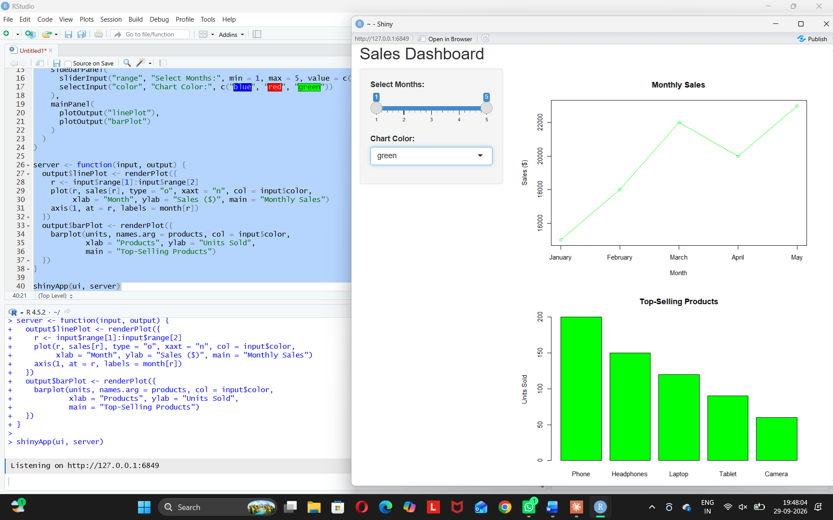
Observation: The user can explore the sales data interactively.

